
LAB ASSIGNMENTS
ON
MCA40290- Full Stack Development
SY MCA: Semester III

Name: Aditya Udhav Gaikwad
PRN: 1272251003 Division: D

Certificate
This is to certify that Mr./Ms.___________________________________________
PRN: _________________a student of SY MCA, Semester III has successfully completed _______ no. of assignments in Lab Course_________________________________ during A.Y. 2026-2027.

Course Teacher Program Head

Program Director
INSTRUCTIONS

Practical Evaluation Format
The internal continuous assessment will be of 15 marks.
Sr. No. | Distribution of Marks | Marks
1 | Lab Continuous Assessment: 1 | 33
2 | Lab Continuous Assessment: 2 | 33
3 | Lab Continuous Assessment: 3 | 34
- About the assignment book
This workbook is intended to be used by students for the laboratory course. In Computer science, hands-on laboratory experience is critical to the understanding of theoretical concepts studied in the theory courses. This assignment bookcovers numerous computing problems covering all difficulty levels. This book will describe the continuous assessment of the course.
- How to use this assignment book
This assignment book is mandatory for the completion of the laboratory course. It is a measure of the performance of the student in the laboratory for the entire duration of the course.
- Instructions to the students
- Students are expected to carry this book every time they come to the lab for practical session.
- Students should solve assignments which are selected by instructor as a part of practical session. Students need to add the outputs of subsequent assignment to this lab manual under each assignment.
- Student will be assessed for each assignment on a scale of 5.
- Instruction to the Instructors
- After a student completes a specific assignment, students have to print specific outputs for assignments and add them under specified assignment question, the instructor has to verify the outputs and sign in the provided space after the activity
- Ensure that the students use good programming practices.
- Instructor should evaluate each assignment carried out by a student on a scale of 5

Lab on Full Stack Development
Index and Evaluation
Sr. No. | Assignment Title | Marks | Signature
1 | ASSIGNMENT NO. 1 | /3
2 | ASSIGNMENT NO. 2 | /3
3 | ASSIGNMENT NO. 3 | /4
4 | ASSIGNMENT NO. 4 | /4
5 | ASSIGNMENT NO. 5 | /4
6 | ASSIGNMENT NO. 6 | /4
7 | ASSIGNMENT NO. 7 | /4
8 | ASSIGNMENT NO. 8 | /4
9 | ASSIGNMENT NO. 9 | /4
Total out of 34

Assignment 1. JavaScript Calculator using Functions
- Aim: To design and implement a basic arithmetic calculator using JavaScript functions and conditional logic.
- Learning Objectives: Understand JavaScript variables, basic operators, function definitions, parameters, and control flow structures (switch or if-else).
- Theoretical Background: JavaScript functions as reusable blocks of code; using conditional statements to route execution based on user input (e.g., operator selection).
- Detailed Requirements:
  - Implement separate helper functions for add(a, b), subtract(a, b), multiply(a, b), and divide(a, b).
  - Implement a driver function or prompt-based interface that takes two numbers and an operator ($+$, $-$, $*$, $/$) as input.
  - Handle edge cases such as division by zero with an appropriate warning.
- Execution Step: Run the script using a browser console, or by embedding it in an HTML file and opening it in a web browser.

Remark: _____________________________________________________________
Start Date: _____________________ Date of Completion: _____________________
Signature of the Instructor: _________________________
Assignment 2. DOM-based To-Do List
- Aim: To build a dynamic, interactive To-Do List application using vanilla HTML, CSS, and JavaScript DOM manipulation.
- Learning Objectives: Understand Document Object Model (DOM) selection methods, event listeners (click, submit), and dynamic element creation/deletion.
- Theoretical Background: The DOM tree representing the page structure; using document.getElementById(), document.createElement(), appendChild(), and addEventListener() to modify UI state dynamically.
- Detailed Requirements:
  - HTML Structure: An input text field, an "Add Task" button, and an empty list container (<ul> or <div>).
  - CSS Styling: Basic clean interface styling, including a visual indicator (like a strikethrough or color change) for completed tasks.
  - JavaScript Logic:
    - Add: Read the input field, create a new list item (<li>) dynamically, and append it to the container.
    - Toggle Complete: Click on a task to toggle a CSS class (e.g., .completed) that visually marks it off.
    - Delete: Add a "Delete" button next to each task that removes that specific node from the DOM when clicked.

Remark: _____________________________________________________________
Start Date: _____________________ Date of Completion: _____________________
Signature of the Instructor: _________________________
Assignment 3. JavaScript Form Validation
- Aim: To build a robust user registration form with client-side input validation using JavaScript.
- Learning Objectives: Understand form submission interception, regular expressions (RegEx) for data pattern matching, and real-time DOM feedback.
- Theoretical Background: Client-side validation improves user experience by correcting inputs before sending them to a server.
- Detailed Requirements:
  - Form Fields: Name (text), Email (email), Phone (tel), Password (password), and a Submit button.
  - Validation Rules:
    - Name: Cannot be empty; must contain only letters (minimum 3 characters).
    - Email: Must match standard email format (use RegEx).
    - Phone: Must be a valid 10-digit numeric value.
    - Password: Minimum 8 characters, containing at least one uppercase letter, one lowercase letter, and one number.
  - Error Handling: Prevent default form submission if any validation fails (event.preventDefault()). Display specific error messages next to or below the respective input fields.

Remark: _____________________________________________________________
Start Date: _____________________ Date of Completion: _____________________
Signature of the Instructor: _________________________
Assignment 4. React Profile Card using Props
- Aim: To build a reusable Profile Card component in React and pass dynamic data using Props.
- Learning Objectives: Set up a React project using Vite or Create React App, understand JSX, functional components, and unidirectional data flow (Props).
- Theoretical Background: Props (properties) are read-only configuration objects passed from parent components to child components to render dynamic data.
- Detailed Requirements:
  - Create a parent component (e.g., App) containing a list of user profiles (objects with name, imageUrl, and description).
  - Create a child functional component named ProfileCard.
  - Pass data from the parent to the child component via props.
  - Render the card with clean UI layout (using inline styles or CSS modules).

Remark: _____________________________________________________________
Start Date: _____________________ Date of Completion: _____________________
Signature of the Instructor: _________________________

Assignment 5. Controlled React Form
- Aim: To design a React form where form elements are controlled by the component's state.
- Learning Objectives: Understand controlled inputs, handling onChange events, updating state in React, and rendering state dynamically.
- Theoretical Background: In a controlled component, the React state serves as the "single source of truth" for the input elements.
- Detailed Requirements:
  - Create a form with fields for Username and Favorite Technology.
  - Bind the value attribute of each input to a local React state variable.
  - Implement an onChange handler to update the state as the user types.
  - Render the entered data dynamically (in real-time) in a preview section directly beneath the form.

Remark: _____________________________________________________________
Start Date: _____________________ Date of Completion: _____________________
Signature of the Instructor: _________________________

Assignment 6. React Counter App using useState
- Aim: To build a functional counter application utilizing React's state management hook.
- Learning Objectives: Understand the lifecycle of state, component re-rendering, and the usage of the useState hook.
- Theoretical Background: Hooks let you use state and other React features without writing a class. The useState hook provides a state variable and a updater function.
- Detailed Requirements:
  - Initialize a state variable count to 0.
  - Provide three distinct buttons:
    - Increment: Adds $1$ to count.
    - Decrement: Subtracts $1$ from count (optionally prevent it from going below $0$).
    - Reset: Sets count back to 0.
  - Ensure the count display updates instantly on the UI upon clicking any button.

Remark: _____________________________________________________________
Start Date: _____________________ Date of Completion: _____________________
Signature of the Instructor: _________________________
Assignment 7. REST API using Express.js
- Aim: To build a backend RESTful web service using Node.js and Express.js to handle standard HTTP requests.
- Learning Objectives: Initialize a Node.js project, handle npm packages, design Express routing, and manage JSON payloads.
- Theoretical Background: REST (Representational State Transfer) architecture uses HTTP verbs (GET, POST, PUT, DELETE) to perform operations on a resource.
- Detailed Requirements:
  - Set up an Express server listening on a local port (e.g., 5000).
  - Define an in-memory array of "User" objects (each containing id, name, and email) to act as a mock database.
  - Implement the following routes:
    - GET /api/users: Fetch all users.
    - POST /api/users: Add a new user (read data from req.body).
    - PUT /api/users/:id: Update user details matching the route parameter :id.
    - DELETE /api/users/:id: Remove the user matching the route parameter :id.
  - Test the endpoints using an API client (like Postman or Thunder Client).

Remark: _____________________________________________________________
Start Date: _____________________ Date of Completion: _____________________
Signature of the Instructor: _________________________
Assignment 8. MongoDB Integration using Mongoose
- Aim: To establish a database connection between an Express application and MongoDB using Mongoose, executing basic CRUD operations.
- Learning Objectives: Understand NoSQL database concepts, design structured schemas using Mongoose, and handle asynchronous database operations (async/await).
- Theoretical Background: Mongoose provides a straight-forward, schema-based solution to model application data with MongoDB.
- Detailed Requirements:
  - Configure a local MongoDB instance or a MongoDB Atlas cloud database.
  - Define a strict Mongoose Schema for a Product (fields: name [String], price [Number], category [String], stock [Number]).
  - Create Express routes to:
    - Create a product (Save to MongoDB).
    - Read products (Find all / Find by ID).
    - Update a product's price or stock.
    - Delete a product by ID.
  - Implement error-handling middleware for database connection failures or missing parameters.

Remark: _____________________________________________________________
Start Date: _____________________ Date of Completion: _____________________
Signature of the Instructor: _________________________
Assignment 9. Full-Stack Integration (React + Express + MongoDB)
- Aim: To connect the React frontend with the Node/Express backend and MongoDB database to form a complete MERN application.
- Learning Objectives: Master Cross-Origin Resource Sharing (CORS) configurations, execute frontend HTTP requests using Axios, and integrate full-stack components.
- Theoretical Background: A full-stack application connects a client layer (React) to a controller/server layer (Express) which persists data to a storage layer (MongoDB).
- Detailed Requirements:
  - Backend:
    - Create an Express server connected to a MongoDB database containing a "User" collection.
    - Expose endpoints to get users and post a new user.
    - Enable cors middleware to allow requests from your React frontend port.
  - Frontend:
    - A React form to input user details (name, email).
    - Use Axios (or the Fetch API) inside a useEffect hook to pull the existing list of users from the backend upon mounting.
    - Submit the form to trigger an Axios POST request, saving the user to the database, and dynamically updating the UI list with the newly added user.

Remark: _____________________________________________________________
Start Date: _____________________ Date of Completion: _____________________
Signature of the Instructor: _________________________

ASSIGNMENT NO. 1
calculator.html
<!DOCTYPE html>
<html lang="en">
<head>
<meta charset="utf-8" />
<meta name="viewport" content="width=device-width, initial-scale=1" />
<title>JavaScript Calculator (Functions)</title>
<style>
body { font-family: Arial, sans-serif; padding: 2rem; }
.calculator { max-width: 420px; margin: 0 auto; }
label { display: block; margin-top: 0.75rem; }
input, select, button { width: 100%; padding: 0.5rem; font-size: 1rem; margin-top: 0.25rem; }
#result { margin-top: 1rem; font-weight: bold; }
</style>
</head>
<body>
<div class="calculator">
<h1>JavaScript Calculator (Functions)</h1>

<label for="num1">First number</label>
<input id="num1" type="number" step="any" placeholder="Enter first number" />

<label for="num2">Second number</label>
<input id="num2" type="number" step="any" placeholder="Enter second number" />

<label for="operator">Operator</label>
<select id="operator">
<option value="+">Addition (+)</option>
<option value="-">Subtraction (-)</option>
<option value="*">Multiplication (*)</option>
<option value="/">Division (/)</option>
</select>

<button id="calcBtn">Calculate</button>

<div id="result" aria-live="polite"></div>

<p style="margin-top:1rem; font-size:0.9rem; color:#555;">You can also open the browser console and call <code>calculateFromConsole(a, b, op)</code>.</p>
</div>

<script src="calculator.js"></script>
</body>
</html>>

calculator.js
// calculator.js
// Helper functions for basic arithmetic operations required by the assignment.

function add(a, b) {
return a + b;
}

function subtract(a, b) {
return a - b;
}

function multiply(a, b) {
return a * b;
}

function divide(a, b) {
// Handle division by zero: return null to indicate an error to the caller.
if (b === 0) {
return null;
}
return a / b;
}

// Driver function used by the UI. Accepts numeric inputs and an operator string.
function calculate(a, b, operator) {
switch (operator) {
case '+':
return add(a, b);
case '-':
return subtract(a, b);
case '*':
return multiply(a, b);
case '/':
return divide(a, b);
default:
return NaN; // unknown operator
}
}

// Convenience function to call from the browser console: calculateFromConsole(2,3,'+')
function calculateFromConsole(a, b, operator) {
const result = calculate(Number(a), Number(b), operator);
if (result === null) {
console.warn('Division by zero is not allowed.');
} else if (Number.isNaN(result)) {
console.warn('Unknown operator. Use one of +, -, *, /.');
} else {
console.log(`${a} ${operator} ${b} = ${result}`);
}
return result;
}

// UI wiring: read values, perform calculation, and show result with division-by-zero warning.
document.addEventListener('DOMContentLoaded', function () {
const num1El = document.getElementById('num1');
const num2El = document.getElementById('num2');
const opEl = document.getElementById('operator');
const btn = document.getElementById('calcBtn');
const resultEl = document.getElementById('result');

btn.addEventListener('click', function () {
const a = Number(num1El.value);
const b = Number(num2El.value);
const op = opEl.value;

// Basic validation
if (num1El.value === '' || num2El.value === '') {
resultEl.textContent = 'Please enter both numbers.';
resultEl.style.color = 'crimson';
return;
}

const res = calculate(a, b, op);

if (res === null) {
resultEl.textContent = 'Warning: Division by zero is not allowed.';
resultEl.style.color = 'crimson';
} else if (Number.isNaN(res)) {
resultEl.textContent = 'Error: Unknown operator.';
resultEl.style.color = 'crimson';
} else {
resultEl.textContent = `Result: ${res}`;
resultEl.style.color = 'black';
}
});
});

// Export functions to the window so they can be tested from the console if desired.
window.add = add;
window.subtract = subtract;
window.multiply = multiply;
window.divide = divide;
window.calculate = calculate;
window.calculateFromConsole = calculateFromConsole;

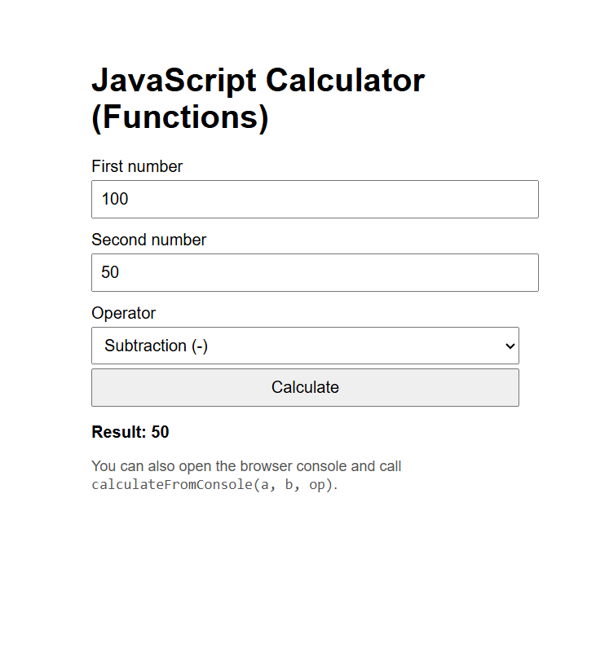

ASSIGNMENT NO. 2 Task manager
Index.html
<!DOCTYPE html>
<html lang="en">
<head>
<meta charset="UTF-8">
<meta name="viewport" content="width=device-width, initial-scale=1.0">
<title>Task Tracker</title>
<link rel="stylesheet" href="style.css">
</head>
<body>
<div class="container">
<h1>Task Tracker</h1>
<div class="task-input">
<input type="text" id="taskInput" placeholder="Enter a task...">
<button id="addTaskBtn">Assign Task</button>
</div>
<div id="taskList"></div>
</div>
<script src="script.js"></script>
</body>
</html>

Style.css
* { box-sizing: border-box; margin: 0; padding: 0; }
body { font-family: Arial, sans-serif; background: #f4f4f4; min-height: 100vh; display: flex; justify-content: center; align-items: center; }
.container { width: 500px; background: white; padding: 30px; border-radius: 10px; box-shadow: 0 5px 20px rgba(0, 0, 0, 0.1); }
h1 { text-align: center; margin-bottom: 25px; }
.task-input { display: flex; gap: 10px; margin-bottom: 25px; }
.task-input input { flex: 1; padding: 12px; border: 1px solid #ccc; border-radius: 5px; font-size: 16px; }
.task-input button { padding: 12px 15px; border: none; border-radius: 5px; background: #333; color: white; cursor: pointer; }
.task-input button:hover { background: #555; }
.task { display: flex; align-items: center; justify-content: space-between; padding: 15px; margin-bottom: 10px; border: 1px solid #ddd; border-radius: 6px; background: #fafafa; }
.task-text { cursor: pointer; flex: 1; }
.task.completed .task-text { text-decoration: line-through; color: #888; }
.task.completed { background: #eee; }
.delete-btn { border: none; background: #d9534f; color: white; padding: 7px 10px; border-radius: 4px; cursor: pointer; }
.delete-btn:hover { background: #c9302c; }

.task input[type="checkbox"] { margin-right: 10px; transform: scale(1.1); }
.task .task-text { margin-left: 8px; }

.task input[type="checkbox"] { margin-right: 10px; transform: scale(1.1); }
.task .task-text { margin-left: 8px; }

Script.js
const taskInput = document.getElementById("taskInput");
const addTaskBtn = document.getElementById("addTaskBtn");
const taskList = document.getElementById("taskList");

let tasks = [];

// Init
document.addEventListener("DOMContentLoaded", () => {
loadTasks();
renderTasks();
});

addTaskBtn.addEventListener("click", addTask);
taskInput.addEventListener("keydown", function (event) {
if (event.key === "Enter") addTask();
});

function addTask() {
const text = taskInput.value.trim();
if (!text) return;

const newTask = { id: Date.now(), text, completed: false };
tasks.push(newTask);
saveTasks();
renderTasks();

taskInput.value = "";
taskInput.focus();
}

function toggleComplete(id) {
const t = tasks.find(x => x.id === id);
if (!t) return;
t.completed = !t.completed;
saveTasks();
renderTasks();
}

function deleteTask(id) {
tasks = tasks.filter(t => t.id !== id);
saveTasks();
renderTasks();
}

function renderTasks() {
taskList.innerHTML = "";

tasks.forEach(t => {
const taskEl = document.createElement("div");
taskEl.className = "task" + (t.completed ? " completed" : "");

const left = document.createElement("div");
left.style.display = "flex";
left.style.alignItems = "center";

const checkbox = document.createElement("input");
checkbox.type = "checkbox";
checkbox.checked = t.completed;
checkbox.addEventListener("change", () => toggleComplete(t.id));

const span = document.createElement("span");
span.className = "task-text";
span.textContent = t.text;
span.addEventListener("click", () => toggleComplete(t.id));

left.appendChild(checkbox);
left.appendChild(span);

const deleteBtn = document.createElement("button");
deleteBtn.className = "delete-btn";
deleteBtn.textContent = "Delete";
deleteBtn.addEventListener("click", () => deleteTask(t.id));

taskEl.appendChild(left);
taskEl.appendChild(deleteBtn);
taskList.appendChild(taskEl);
});
}

function saveTasks() {
localStorage.setItem("tasks", JSON.stringify(tasks));
}

function loadTasks() {
try {
const raw = localStorage.getItem("tasks");
tasks = raw ? JSON.parse(raw) : [];
} catch (e) {
tasks = [];
}
}

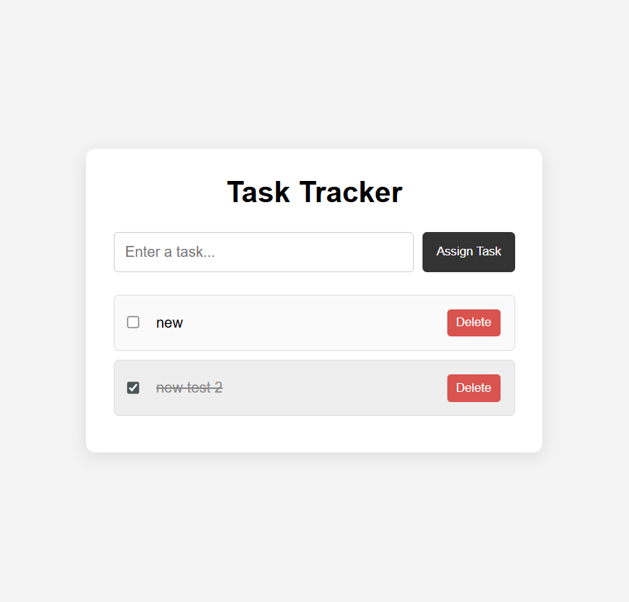

ASSIGNMENT NO 3. JavaScript Form Validation
App.jsx
import React, { useState } from 'react';
import './App.css';

const initialForm = {
name: '',
email: '',
phone: '',
password: ''
};

const initialErrors = {
name: '',
email: '',
phone: '',
password: ''
};

function App() {
const [formData, setFormData] = useState(initialForm);
const [errors, setErrors] = useState(initialErrors);
const [isSubmitted, setIsSubmitted] = useState(false);

const validateField = (name, value) => {
switch (name) {
case 'name':
if (!value.trim()) return 'Name is required.';
if (!/^[A-Za-z]{3,}$/.test(value.trim())) return 'Name must contain only letters and at least 3 characters.';
return '';
case 'email':
if (!value.trim()) return 'Email is required.';
if (!/^[^\s@]+@[^\s@]+\.[^\s@]+$/.test(value.trim())) return 'Please enter a valid email address.';
return '';
case 'phone':
if (!value.trim()) return 'Phone number is required.';
if (!/^\d{10}$/.test(value.trim())) return 'Phone number must be exactly 10 digits.';
return '';
case 'password':
if (!value) return 'Password is required.';
if (!/^(?=.*[a-z])(?=.*[A-Z])(?=.*\d).{8,}$/.test(value)) return 'Password must be at least 8 characters with an uppercase letter, lowercase letter, and number.';
return '';
default:
return '';
}
};

const handleChange = (event) => {
const { name, value } = event.target;

setFormData((prevState) => ({
...prevState,
[name]: value
}));

const fieldError = validateField(name, value);
setErrors((prevErrors) => ({
...prevErrors,
[name]: fieldError
}));

if (isSubmitted) {
setIsSubmitted(false);
}
};

const handleSubmit = (event) => {
event.preventDefault();

const nextErrors = {};
let hasError = false;

Object.keys(formData).forEach((field) => {
const errorMessage = validateField(field, formData[field]);
nextErrors[field] = errorMessage;
if (errorMessage) hasError = true;
});

setErrors(nextErrors);

if (hasError) {
setIsSubmitted(false);
return;
}

setIsSubmitted(true);
setFormData(initialForm);
setErrors(initialErrors);
};

return (
<div className="app-container">
<div className="form-card">
<h1>User Registration</h1>
<form onSubmit={handleSubmit} noValidate>
<div className="field-group">
<label htmlFor="name">Name</label>
<input
type="text"
id="name"
name="name"
value={formData.name}
onChange={handleChange}
placeholder="Enter your name"
className={errors.name ? 'input-error' : ''}
/>
{errors.name && <span className="error-message">{errors.name}</span>}
</div>

<div className="field-group">
<label htmlFor="email">Email</label>
<input
type="email"
id="email"
name="email"
value={formData.email}
onChange={handleChange}
placeholder="Enter your email"
className={errors.email ? 'input-error' : ''}
/>
{errors.email && <span className="error-message">{errors.email}</span>}
</div>

<div className="field-group">
<label htmlFor="phone">Phone</label>
<input
type="tel"
id="phone"
name="phone"
value={formData.phone}
onChange={handleChange}
placeholder="10-digit phone number"
className={errors.phone ? 'input-error' : ''}
/>
{errors.phone && <span className="error-message">{errors.phone}</span>}
</div>

<div className="field-group">
<label htmlFor="password">Password</label>
<input
type="password"
id="password"
name="password"
value={formData.password}
onChange={handleChange}
placeholder="Create a password"
className={errors.password ? 'input-error' : ''}
/>
{errors.password && <span className="error-message">{errors.password}</span>}
</div>

<button type="submit" className="submit-button">Submit</button>
{isSubmitted && <p className="success-message">Registration successful!</p>}
</form>
</div>
</div>
);
}

export default App;

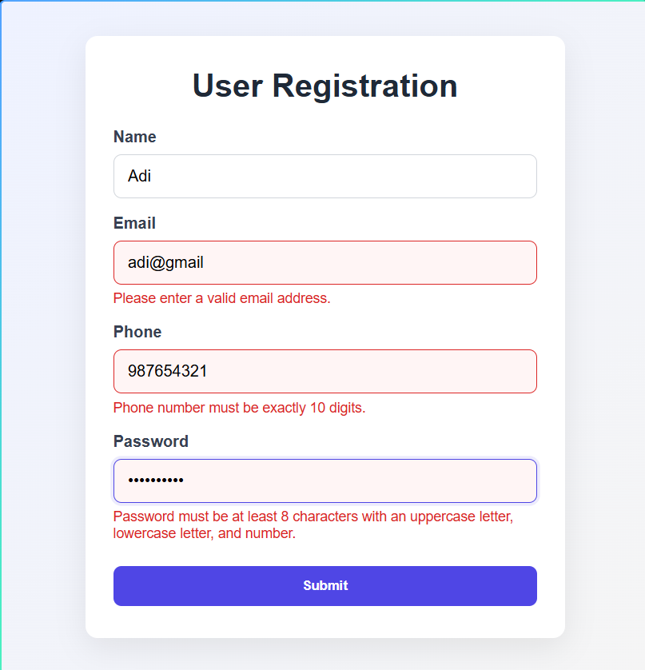

ASSIGNMENT NO 4. Profile Card
App.jsx
const profiles = [
{
name: 'Aarav Mehta',
role: 'Frontend Developer',
imageUrl: 'https://i.pravatar.cc/240?img=12',
description: 'Builds thoughtful interfaces and turns complex ideas into simple experiences.',
accent: 'coral',
},
{
name: 'Maya Chen',
role: 'Product Designer',
imageUrl: 'https://i.pravatar.cc/240?img=47',
description: 'Creates warm, accessible products where every interaction has a purpose.',
accent: 'mint',
},
{
name: 'Noah Williams',
role: 'Data Scientist',
imageUrl: 'https://i.pravatar.cc/240?img=53',
description: 'Finds the story in the numbers and helps teams make confident decisions.',
accent: 'gold',
},
]

function ProfileCard({ name, role, imageUrl, description, accent }) {
return (
<article className={`profile-card profile-card--${accent}`}>
<div className="profile-card__topline" />
<img className="profile-card__image" src={imageUrl} alt={`${name} profile`} />
<div className="profile-card__content">
<p className="profile-card__role">{role}</p>
<h2>{name}</h2>
<p className="profile-card__description">{description}</p>
<button className="profile-card__button" type="button">View profile <span aria-hidden="true">↗</span></button>
</div>
</article>
)
}

function App() {
return (
<main className="page-shell">
<header className="page-header">
<p className="eyebrow">Assignment 04 / React fundamentals</p>
<h1>Meet the people<br /><em>behind the work.</em></h1>
<p className="intro">A reusable profile card, powered by a single list of data and passed down through props.</p>
</header>

<section className="profile-grid" aria-label="Profile cards">
{profiles.map((profile) => (
<ProfileCard key={profile.name} {...profile} />
))}
</section>

<footer className="page-footer">
<span>React / Props / Components</span>
<span>03 profiles</span>
</footer>
</main>
)
}

export default App

index.css
@import url('https://fonts.googleapis.com/css2?family=DM+Mono:wght@400;500&family=DM+Sans:wght@400;500;700&family=Playfair+Display:ital,wght@0,600;1,600&display=swap');

:root {
font-family: 'DM Sans', sans-serif;
color: #263238;
background: #f4efe8;
font-synthesis: none;
text-rendering: optimizeLegibility;
}

* { box-sizing: border-box; }
body { margin: 0; min-width: 320px; }
button { font: inherit; }

.page-shell {
min-height: 100vh;
padding: 64px clamp(24px, 7vw, 112px) 32px;
background: radial-gradient(circle at 90% 8%, #f9cfaa 0, transparent 24%), #f4efe8;
}

.page-header { max-width: 760px; }
.eyebrow, .profile-card__role, .page-footer {
font-family: 'DM Mono', monospace;
letter-spacing: .08em;
text-transform: uppercase;
}
.eyebrow { margin: 0 0 22px; color: #c85b45; font-size: .72rem; }
h1 { margin: 0; color: #263238; font-size: clamp(3.2rem, 8vw, 7.4rem); font-weight: 500; letter-spacing: -.06em; line-height: .9; }
h1 em { color: #c85b45; font-family: 'Playfair Display', serif; font-weight: 600; letter-spacing: -.04em; }
.intro { max-width: 390px; margin: 32px 0 0 2px; color: #6c716c; font-size: 1rem; line-height: 1.6; }

.profile-grid { display: grid; grid-template-columns: repeat(3, 1fr); gap: 20px; margin-top: 72px; }
.profile-card { position: relative; overflow: hidden; min-height: 430px; background: #fffdf9; box-shadow: 0 18px 50px rgba(60, 48, 38, .08); }
.profile-card__topline { height: 8px; background: #e8775d; }
.profile-card--mint .profile-card__topline { background: #78a995; }
.profile-card--gold .profile-card__topline { background: #e8b24d; }
.profile-card__image { display: block; width: 100%; height: 220px; object-fit: cover; filter: saturate(.82); }
.profile-card__content { padding: 24px 26px 26px; }
.profile-card__role { margin: 0 0 10px; color: #8b918a; font-size: .65rem; }
h2 { margin: 0; color: #263238; font-size: 1.65rem; letter-spacing: -.04em; }
.profile-card__description { min-height: 72px; margin: 14px 0 22px; color: #6c716c; font-size: .92rem; line-height: 1.55; }
.profile-card__button { padding: 0; border: 0; color: #263238; background: transparent; cursor: pointer; font-weight: 700; }
.profile-card__button span { display: inline-block; margin-left: 8px; color: #c85b45; transition: transform .2s ease; }
.profile-card__button:hover span { transform: translate(3px, -3px); }
.page-footer { display: flex; justify-content: space-between; margin-top: 72px; padding-top: 18px; border-top: 1px solid #d8d0c6; color: #8b918a; font-size: .65rem; }

@media (max-width: 800px) {
.page-shell { padding-top: 40px; }
.profile-grid { grid-template-columns: 1fr; max-width: 480px; margin-top: 48px; }
.profile-card { min-height: 0; }
.profile-card__image { height: 240px; }
.page-footer { margin-top: 48px; }
}

main.jsx
import { StrictMode } from 'react'
import { createRoot } from 'react-dom/client'
import App from './App.jsx'
import './index.css'

createRoot(document.getElementById('root')).render(
<StrictMode>
<App />
</StrictMode>,
)

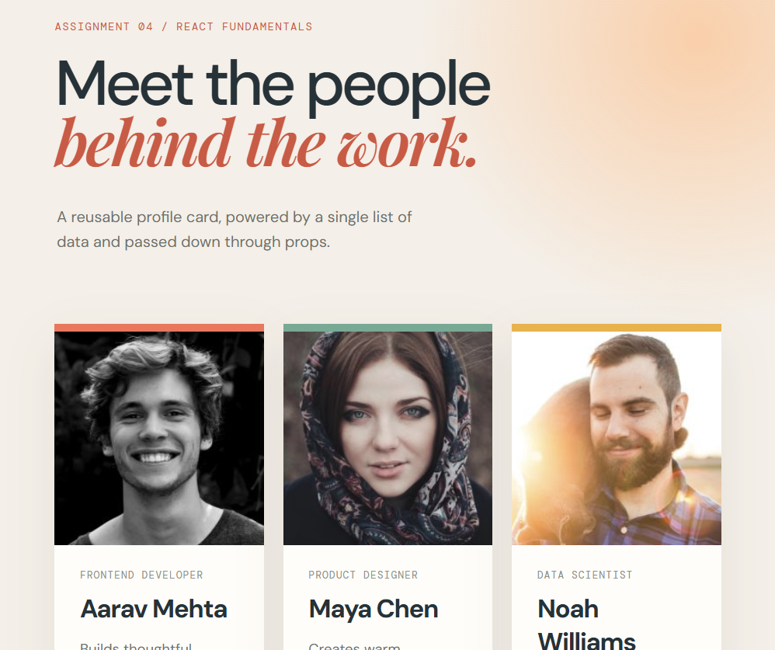

Assignment 5. Controlled React Form
App.jsx
import React, { useState } from 'react';
import './App.css';

const initialForm = {
name: '',
email: '',
phone: '',
password: ''
};

const initialErrors = {
name: '',
email: '',
phone: '',
password: ''
};

function App() {
const [formData, setFormData] = useState(initialForm);
const [errors, setErrors] = useState(initialErrors);
const [isSubmitted, setIsSubmitted] = useState(false);

const validateField = (name, value) => {
switch (name) {
case 'name':
if (!value.trim()) return 'Name is required.';
if (!/^[A-Za-z]{3,}$/.test(value.trim())) return 'Name must contain only letters and at least 3 characters.';
return '';
case 'email':
if (!value.trim()) return 'Email is required.';
if (!/^[^\s@]+@[^\s@]+\.[^\s@]+$/.test(value.trim())) return 'Please enter a valid email address.';
return '';
case 'phone':
if (!value.trim()) return 'Phone number is required.';
if (!/^\d{10}$/.test(value.trim())) return 'Phone number must be exactly 10 digits.';
return '';
case 'password':
if (!value) return 'Password is required.';
if (!/^(?=.*[a-z])(?=.*[A-Z])(?=.*\d).{8,}$/.test(value)) return 'Password must be at least 8 characters with an uppercase letter, lowercase letter, and number.';
return '';
default:
return '';
}
};

const handleChange = (event) => {
const { name, value } = event.target;

setFormData((prevState) => ({
...prevState,
[name]: value
}));

const fieldError = validateField(name, value);
setErrors((prevErrors) => ({
...prevErrors,
[name]: fieldError
}));

if (isSubmitted) {
setIsSubmitted(false);
}
};

const handleSubmit = (event) => {
event.preventDefault();

const nextErrors = {};
let hasError = false;

Object.keys(formData).forEach((field) => {
const errorMessage = validateField(field, formData[field]);
nextErrors[field] = errorMessage;
if (errorMessage) hasError = true;
});

setErrors(nextErrors);

if (hasError) {
setIsSubmitted(false);
return;
}

setIsSubmitted(true);
setFormData(initialForm);
setErrors(initialErrors);
};

return (
<div className="app-container">
<div className="form-card">
<h1>User Registration</h1>
<form onSubmit={handleSubmit} noValidate>
<div className="field-group">
<label htmlFor="name">Name</label>
<input
type="text"
id="name"
name="name"
value={formData.name}
onChange={handleChange}
placeholder="Enter your name"
className={errors.name ? 'input-error' : ''}
/>
{errors.name && <span className="error-message">{errors.name}</span>}
</div>

<div className="field-group">
<label htmlFor="email">Email</label>
<input
type="email"
id="email"
name="email"
value={formData.email}
onChange={handleChange}
placeholder="Enter your email"
className={errors.email ? 'input-error' : ''}
/>
{errors.email && <span className="error-message">{errors.email}</span>}
</div>

<div className="field-group">
<label htmlFor="phone">Phone</label>
<input
type="tel"
id="phone"
name="phone"
value={formData.phone}
onChange={handleChange}
placeholder="10-digit phone number"
className={errors.phone ? 'input-error' : ''}
/>
{errors.phone && <span className="error-message">{errors.phone}</span>}
</div>

<div className="field-group">
<label htmlFor="password">Password</label>
<input
type="password"
id="password"
name="password"
value={formData.password}
onChange={handleChange}
placeholder="Create a password"
className={errors.password ? 'input-error' : ''}
/>
{errors.password && <span className="error-message">{errors.password}</span>}
</div>

<button type="submit" className="submit-button">Submit</button>
{isSubmitted && <p className="success-message">Registration successful!</p>}
</form>
</div>
</div>
);
}

export default App;

main.jsx
import React from 'react';
import ReactDOM from 'react-dom';
import App from './App';
import './App.css';

ReactDOM.render(
<React.StrictMode>
<App />
</React.StrictMode>,
document.getElementById('root')
);
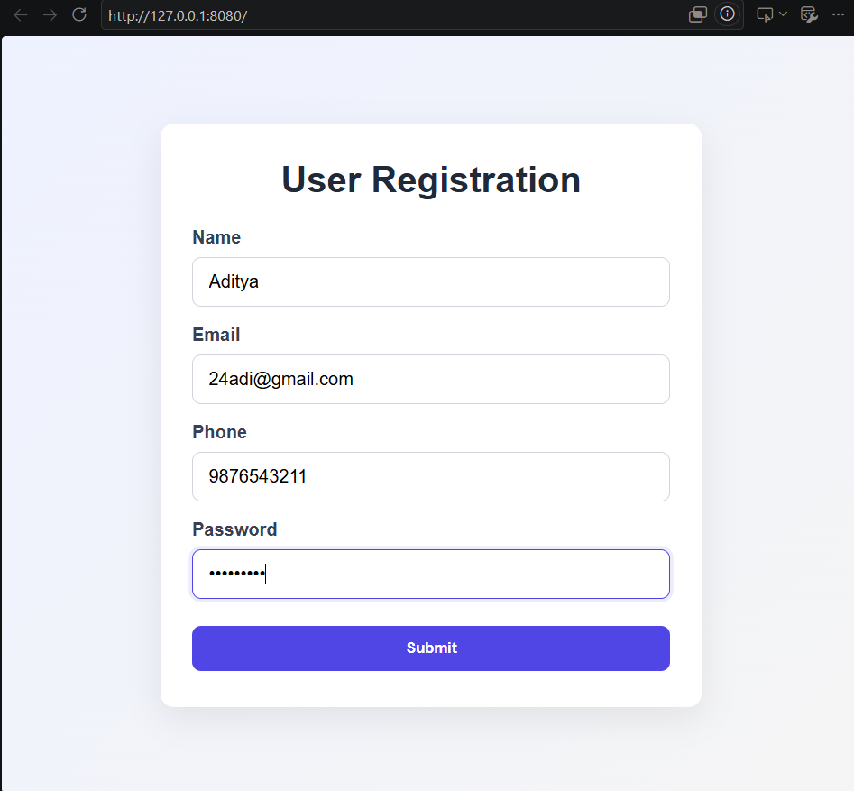

Assignment 6. React Counter App using useState
App.jsx
import React, { useState } from 'react';

function App() {
const [count, setCount] = useState(0);

const decrement = () => {
setCount((currentCount) => Math.max(0, currentCount - 1));
};

return (
<main className="page">
<section className="counter-card" aria-labelledby="counter-title">
<p className="eyebrow">REACT • USESTATE</p>
<h1 id="counter-title">Counter</h1>
<p className="description">A little progress, one click at a time.</p>

<output className="count" aria-live="polite" aria-atomic="true">
{count}
</output>

<div className="controls" aria-label="Counter controls">
<button
className="control-button secondary"
type="button"
onClick={decrement}
disabled={count === 0}
aria-label="Decrement count"
>
<span aria-hidden="true">−</span>
</button>
<button
className="control-button primary"
type="button"
onClick={() => setCount((currentCount) => currentCount + 1)}
aria-label="Increment count"
>
<span aria-hidden="true">+</span>
</button>
</div>

<button
className="reset-button"
type="button"
onClick={() => setCount(0)}
>
Reset counter
</button>
</section>
</main>
);
}

export default App;

main.jsx
import React from 'react';
import ReactDOM from 'react-dom';
import App from './App';
import './App.css';

ReactDOM.render(
<React.StrictMode>
<App />
</React.StrictMode>,
document.getElementById('root')
);

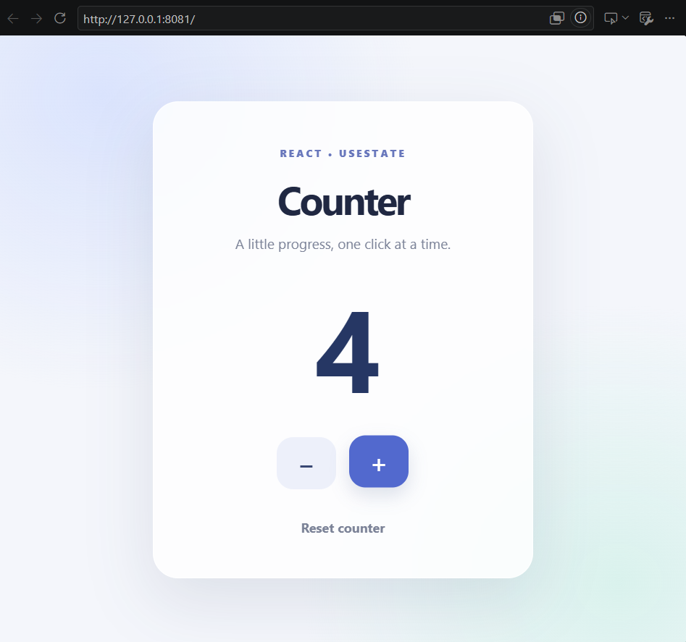s

